CS 630
HOMEWORK 3
ANOOHYA VEERAPANENI
U43071771

1ANS
We have m computers(m1,m2,m3..). The each job takes t1,t2,t3.. time to complete. For the assignment A we assign a computer. A[i]=m_{i}. the a[i] jobs are assigned to i machine. If L is the load of the machine, then assign a job that the machine can perform with in its threshold. So, we have to arrange the machines in the order of its performance and load with best to least, And assign the job in the potential it needs.
So, after arranging the jobs also in the potential it needs most to lowest, they are assigned to its machine. This way we can adjust with the minimum time. It will balance the load and the work and time. It matches up with the machine with its best performance it can do by assigning the right job. We also have to make sure that the job that is given to a machine is within its threshold/Load capacity .

2 ANS
After implementing the graph with the vertices and edges. If we have to delete any edges, we have to check after deleting If the graph disconnects or not. If it disconnects, we simply cannot take it, and if it does not disconnect, we can remove it.
We will find the connection by going through all the vertex and its edges. If each node is connected to the other and it gets back to the final node that we have to reach. We mark all the nodes as visited. The directed graph has a cycle. We have to remove the edges so it is disconnected.

3 ANS
So, here we have 5 seamstresses and the fabric they need for n costumes by the start of the Halloween. Let’s consider that the seamstresses(A,B,C,D,E) in the order to the most professional also stiches fast to least professional. The amount of fabric that each seamstress can handle a day is given. The fabric that each costume take is also known. Now, we arrange the seamstresses in the order of most professional to least. And also, the costumes in order that takes the most time and fabric to that takes least time. Here, A is most productive and costume f1 take more time. E being the less productive and some costume fn takes less times.
If B can stich s2 quantity of fabric and costumes f2,f3 together needs s2 amount of fabric, Both of them can be assigned to B. So, the S(A,B,C,D,E)= F (1,2,3,4,5…N).

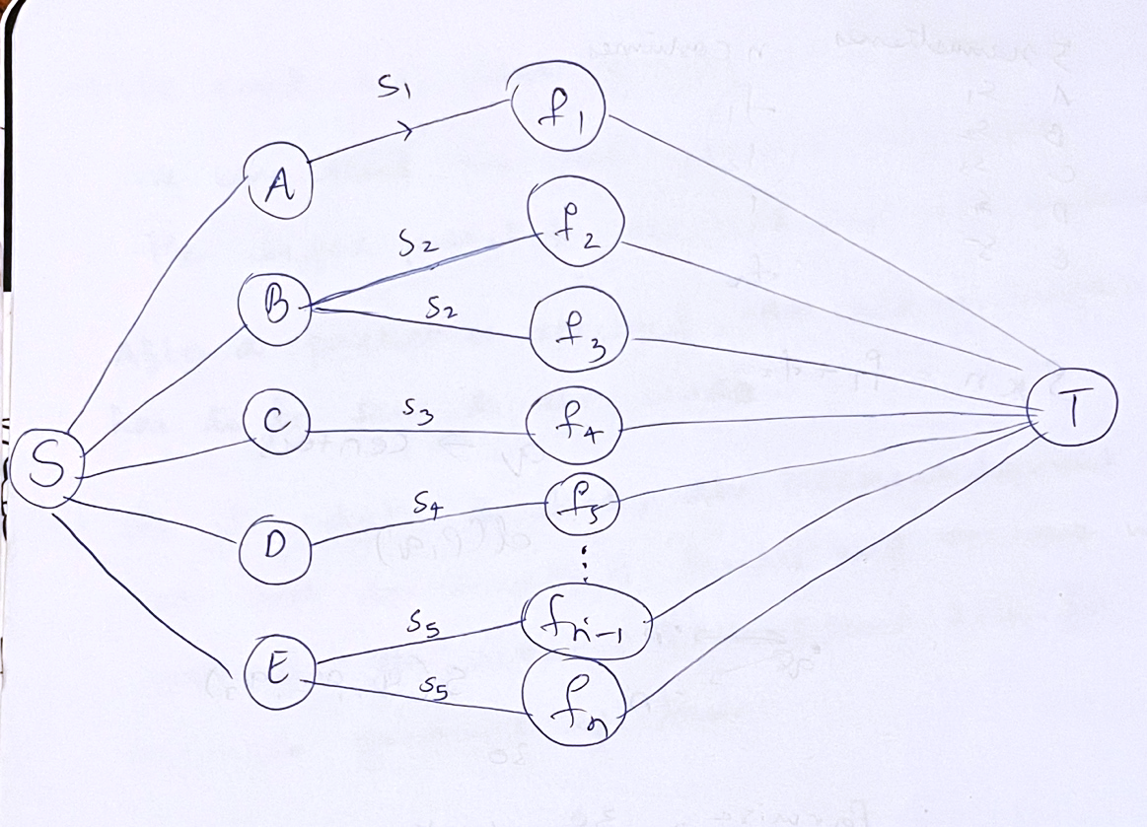

In this way we balance the time. So, every costume takes almost same time to get finished. Because we provided the one costumes which take longer time to the person who stiches quick. When compared, if A is taking x hours to complete her work, E will also take less or more the same time. This way we complete the whole work in minimum time possible. Because, imagine if the costumes that take more time is given to the one that is medium productive (like C in this case). It will take definitely more than x hours and the more productive one will be left with no work and less productive seamstress will be still working. In which case the take consuming will be more to complete the whole work.

4 ANS
From the question, we understood that a vaccine is tested on set of people such that each person covers their similar characteristics of people near to them. All the set of people should be able to cover the total targeted population. S is the set of people on whom the vaccine is being tested(q-representatives). Suppose for a person p matches his characteristics to some q, that means that q is in a distance of d(p,q). ∆ >= d(p,q). And, for every p there has to be a q in set S.

For every q it covers some p’s, so that it covers all the population. The quantity which each q covers is considered as one site(cluster).

So, here we are considering r= pairwise distance/2.
We start from one corner of a cluster and make it to all the other. So, r in the first step covers some distance. We check if r is touching any other person or any other cluster. If it is in contact with all the other ones, that means we go to half of r again.
R_{new} = r/2. In this distance again we try see if it covers any nearby persons other than the ones already in its circle. If it does, we try to add them in the optimal cluster by breaking the other circle. And we only do this if it’s less than R_{new} distance. So, It does not have to necessarily cover all the people in the other clusters but it can at least cover a few. The other remaining ones we try to add into the near clusters. If there Is any one or few persons left, in this case if push them into the nearest cluster that also at most covers the characteristics of that person. This way we can limit the number of q (the representatives). We repeat it until we cover all the sites. So, we will be able to cover all the targeted population .

